Software engineering for big data analaysis

CSA-1035

EXP NO: 6

6 . Draw a USE-CASE diagram for Online college management System Manage student’s information and status, manage courses and subjects, Manage Instructors and designation, record all transactions Draw a USE-CASE diagram for Online Airline Management System which is a dedicated and highly configurable system for all airlines, which can be easily accessed by all users. It helps the users to book flights without visiting offline booking counters. This system can be accessible by any user from any location at any time. In such a system, a passenger should be able to view the availability of flights’ details, as per their requirement. They can book the flights online and can also cancel the reservation. The administrator manages the passenger booking system and updates the reservation status using CASE tools.

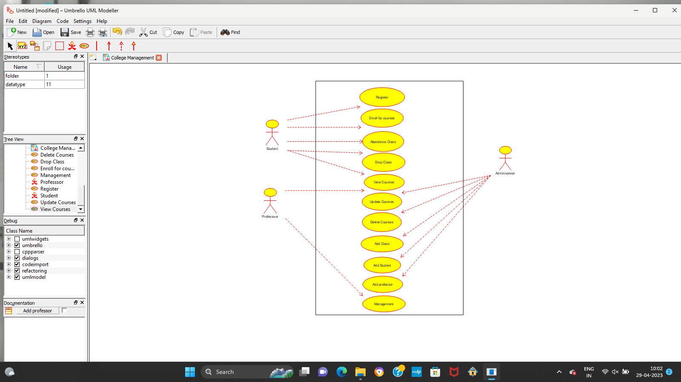

Result:-

Thus the use-case diagram for Hospital management is drawn and verified successfully.